Elastic Search

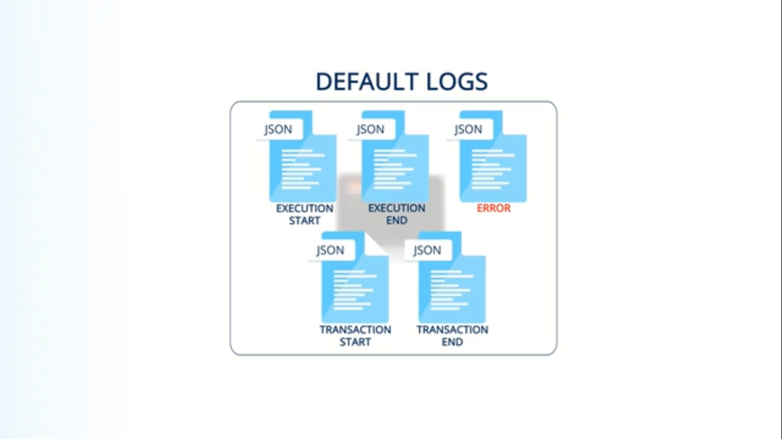

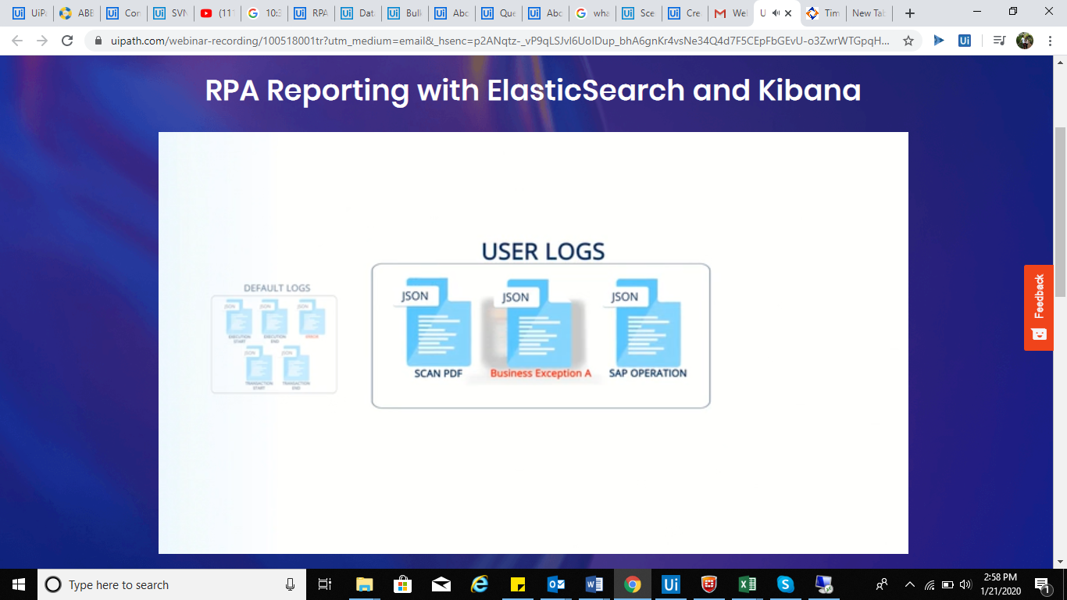

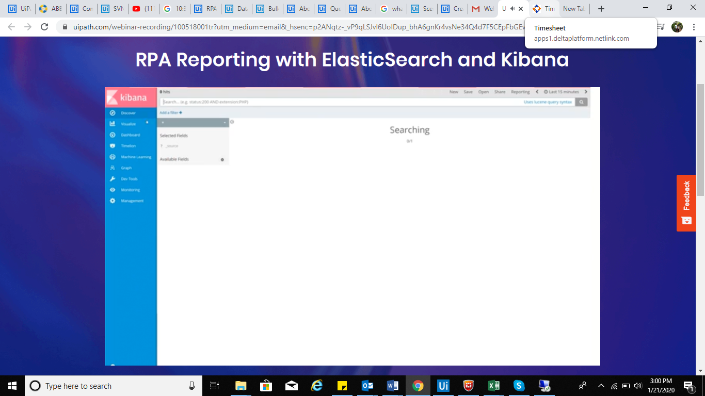

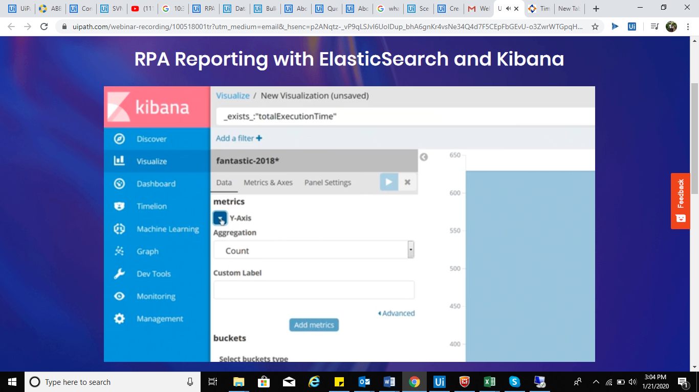

Monitoring and reporting on RPA execution are an essential part of building and managing a virtual workforce. The UiPath robots provide, without any need for additional coding, the ability to perform basic reporting on the logs they generate by default, which are stored in ElasticSearch and analyzed in Kibana.

Top of Form

1. Download Elasticsearch ans start the Elastic Search Windows installer. The Elastisearch wizard is displayed, at the **Locations** step.
2. Now use the default directories for installation, data, configuration, and logs, or select custom locations for each.  
     
   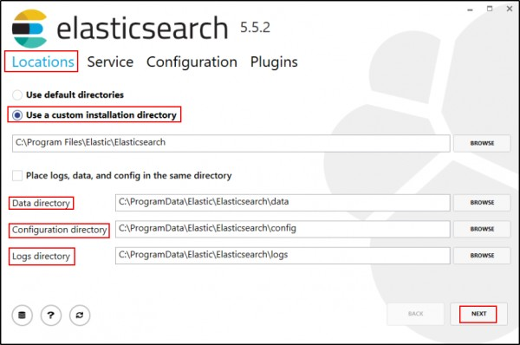
3. Click **Next**. The **Service** step is displayed. Ensure that the following options are selected:
   * **Install as a service**
   * Start the service after this installation is complete
   * Start the service when Windows starts (Automatic)  
       
     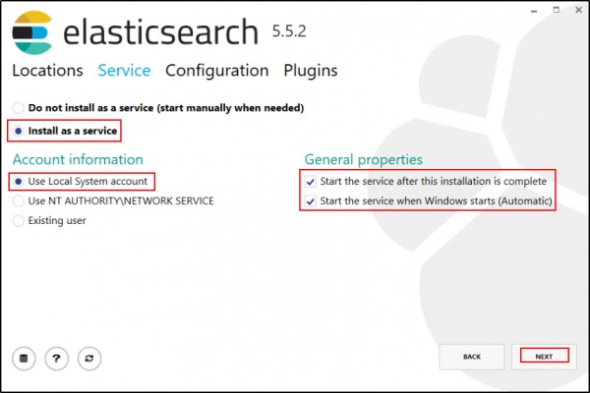
4. Click **Next**. Now the **Configuration** step is displayed. Configure the following options as desired:
   * **Cluster name** - change the value to something that reflects the purpose of this Elasticsearch installation. This is important if you have several servers with Elasticsearch in your intranet, to avoid autodiscovery.
   * **Node name** - a friendly name for your node.
   * **Roles** - the default options are recommended.
   * **Memory** - the default options are recommended.
   * **Network host** - the computer’s hostname/IP address (you can obtain the machine name in a command prompt by running the command hostname).
   * **HTTP Port** - the default port for Elasticsearch is 9200  
       
     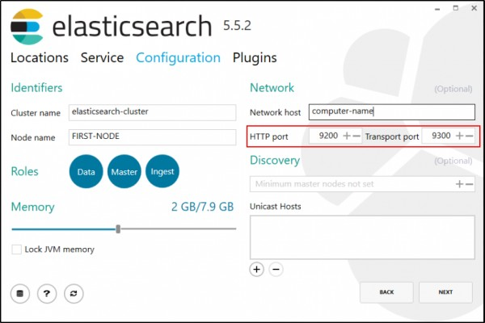
5. Click **Next**. The **Plugins** step is displayed.
6. Select additional plugins for Elasticsearch, such as X-Pack for security.
7. Click **Install**. ElasticSearch is installed.   
     
   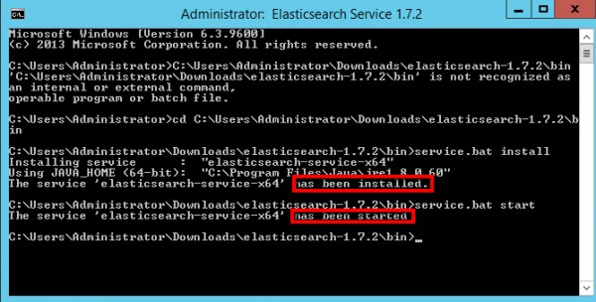

Bottom of Form